

As of PowerSchool 9.0, released in June 2015, Parent Single Sign-On is the only supported

method of parent access to PowerSchool.

Parent Single Sign-On changes the way in which parents access their students’ academic

records using the PowerSchool Parent Portal. This Quick Reference Guide is designed to assist

you through the process of enabling and setting up Parent Single Sign-On in PowerSchool.

1. In your browser, go to <https://powerschool.dvsdedu.org/public>
2. When you see this screen, click on the tab Create Account

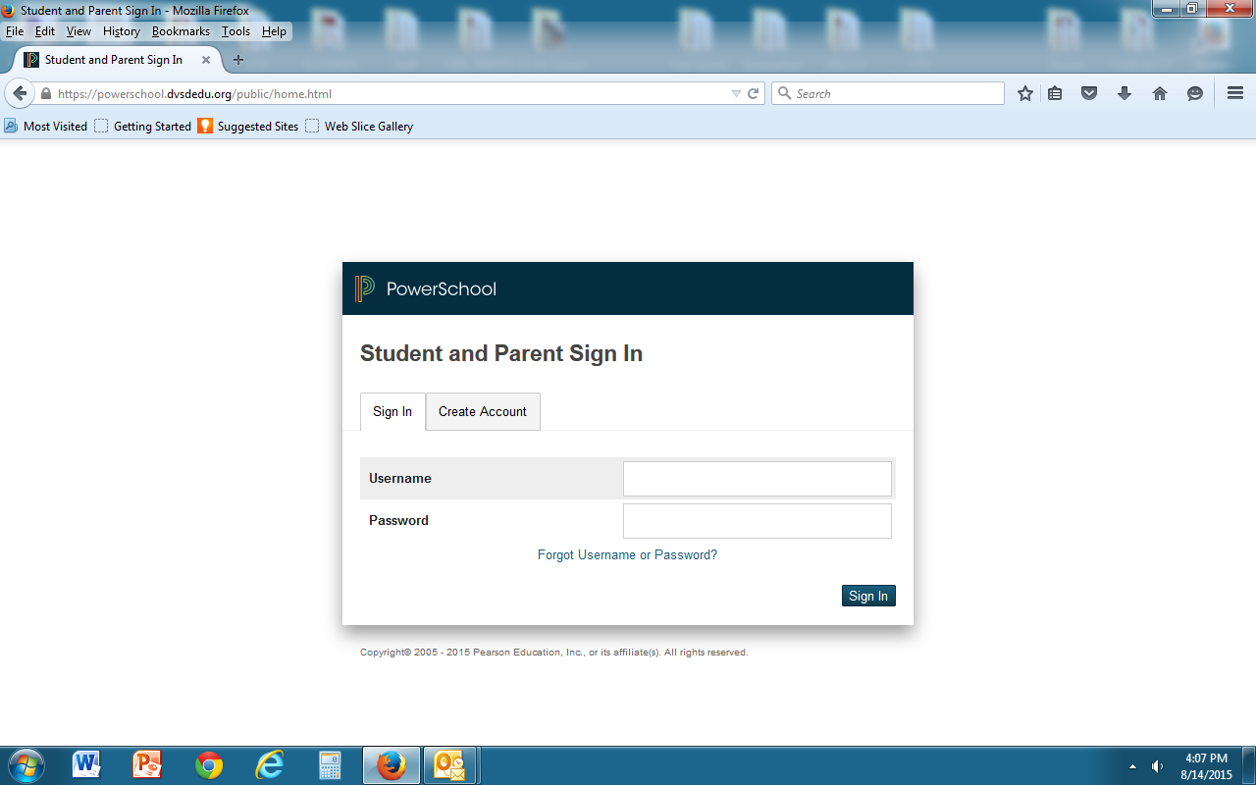

1. Click on Create Account

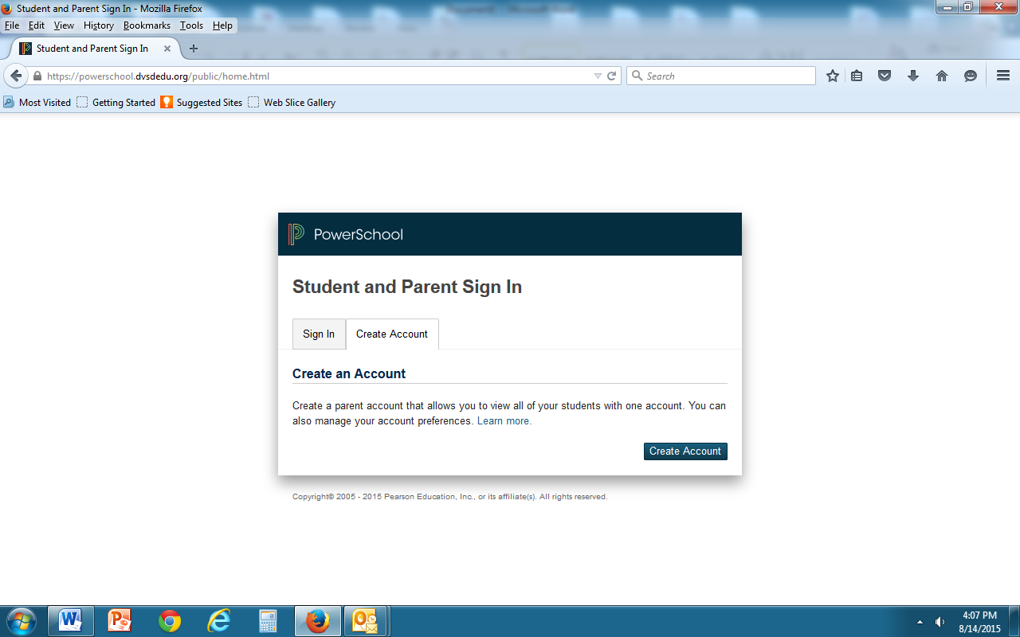

1. Complete the information. ***Please Note:*** the Desired Username and Password you create will be the Username and Password you will use from now on when signing into PowerSchool.

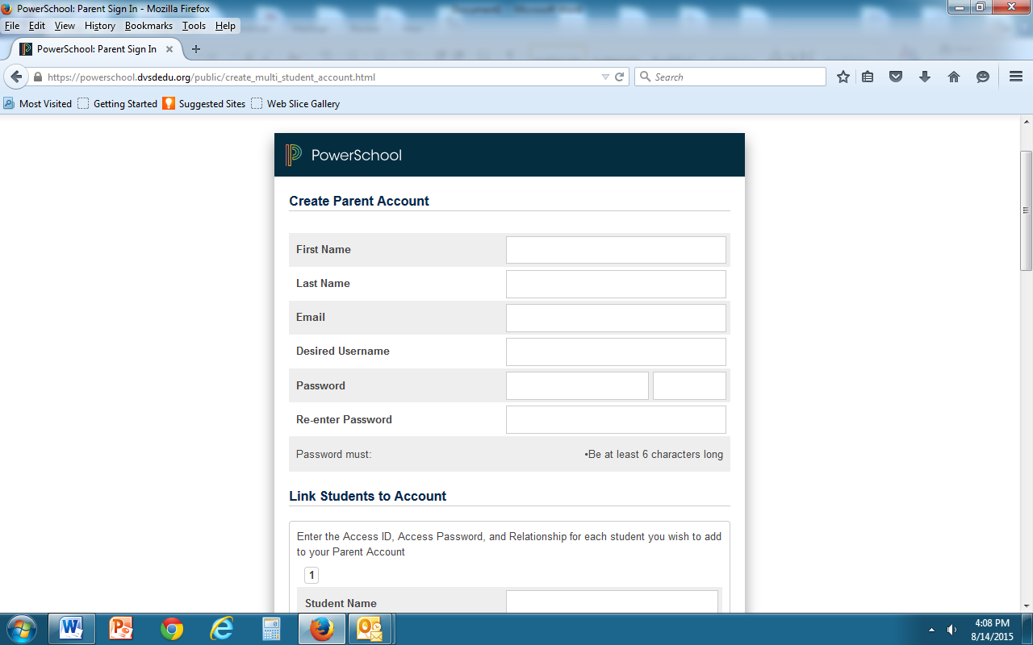

1. Complete your students information. Parents may enter the information for up to seven students when initially establishing their account.

***PLEASE NOTE:*** The Access ID and Access Password for your student is in the letter that was sent to you via USP mail.

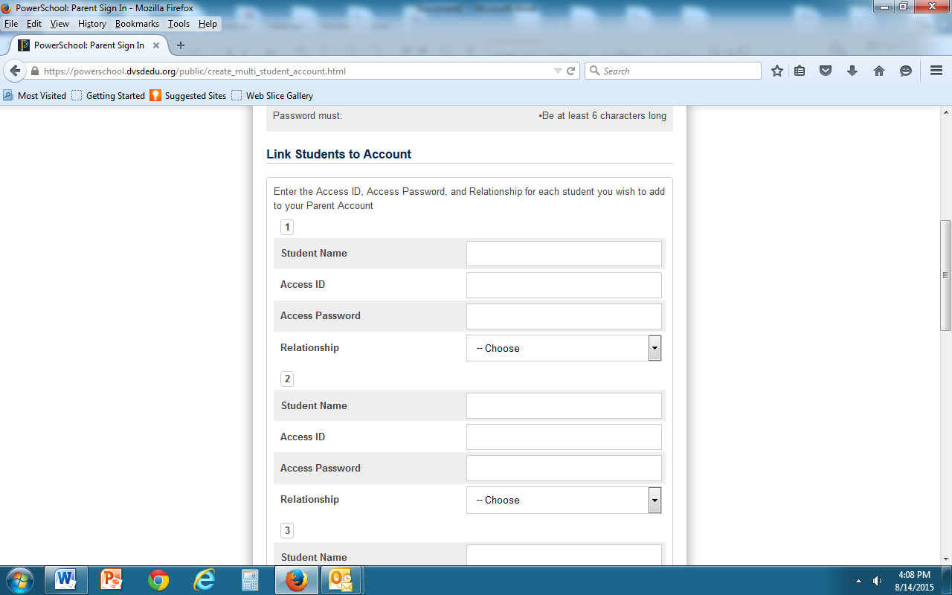

1. When finished entering your student(s), click on Enter.

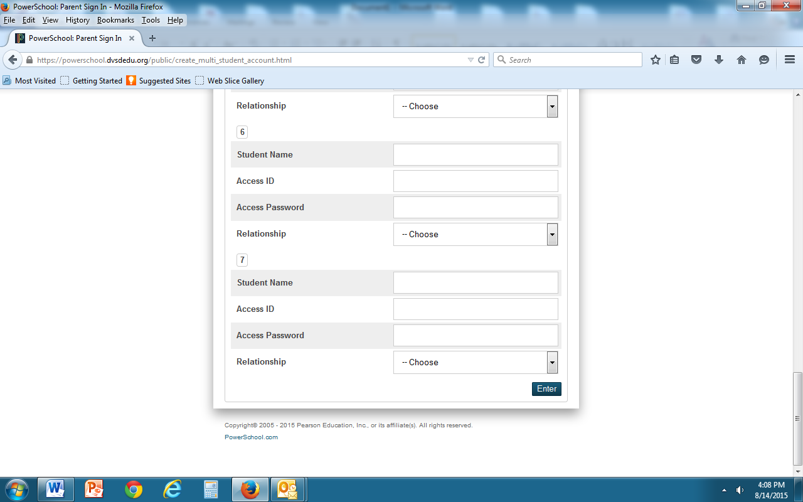

1. You will now see this screen again. Sign in with the Username and Password that you created in the previous screen.

